Diphthongs

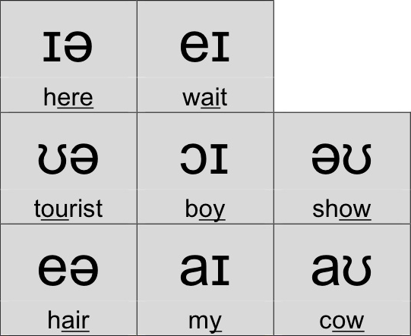

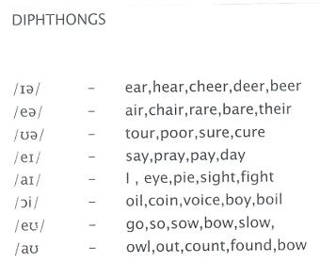

Ending Voiced vs. Unvoiced Consonants

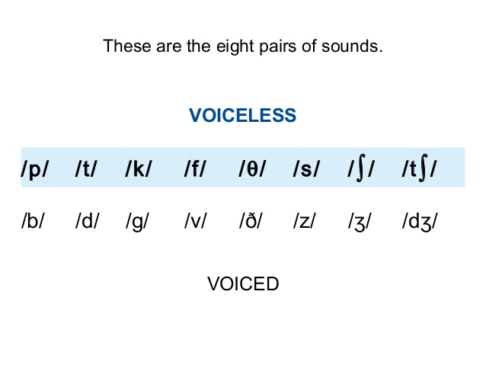

Voiced:

All Vowels

All Diphthongs

Certain consonants

M [m], B[b], z

Unvoiced

Certain consonants

Examples:

h[h], sh, t [t], p [p]

Pair

Unvoiced - Voiced

CH [tʃ] - J [dʒ]

Flowers /ˈflaʊ.ɚz / more like[s], unvoiced

Dive /daiv] more like [f], unvoiced weak.

Garage /ɡəˈrɑːʒ/ , more like [ʃ] , unvoiced weak.

Badge /bædʒ/ vs batch /bætʃ/

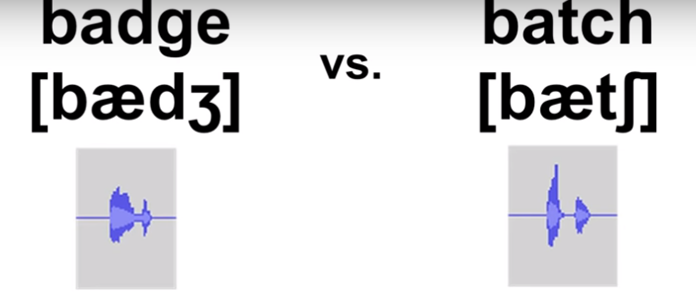

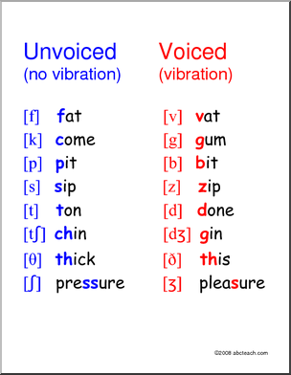

 If the ending, weak voiced consonant links into a vowel, it’s not really that weak anymore.

How to Pronounce -ed verb endings: American English Pronunciation

Case 1: Final sound of infinitive form is **unvoiced consonant** ending -ed = [t]

 /ʧ/, /s/, /k/, /f/, /p/, /θ/, /∫/.

K , P ignore.

F keep.

CHED = CH + T

Exceptions:

He hop~~ed~~ to get her phone number

Case 2: __ Voiced consonant vowel, or diphthong ending. -ed = [d]

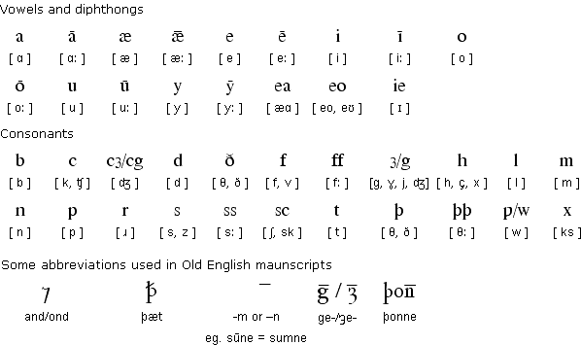

* GỌn

Case 3: Verb ends in [t] or [d] -ed = [id]